Indian E-Commerce Sales &
Customer Behavior Analytics
Project Report
Author: Subhadip Dutta
Dataset: Indian E-Commerce Customer Behavior & Purchase | 25,000 Sessions | 2024
Tools: Python 3.13 · Pandas · NumPy · Matplotlib · Seaborn · Plotly · Scikit-learn

1. Key Performance Indicators
Live values computed from the executed notebook on the full 25,000-session dataset.
Total Revenue  ₹1,01,16,169 | Total Sessions  25,000 | Total Purchases  5,616 | Conversion Rate  22.46% | Avg Order Value  ₹1,801.31 | Cart Abandon Rate  42.00%

2. Dataset Overview
Shape: 25,000 rows × 29 columns | No missing values | No duplicate rows | Data types: 23 integer, 4 float, 2 string columns | Memory: 5.9 MB
Metric | Value
Total Rows | 25,000
Total Columns | 29
Missing Values | 0
Duplicate Rows | 0
Purchased Sessions | 5,616 (22.46%)
Not Purchased | 19,384 (77.54%)
Date Range | Jan 2024 – Dec 2024
Unique Customers | ~10,000
Unique Products | ~900
Unique Locations | 216

3. Purchase Outcome Distribution
Not Purchased: 19,384 sessions (77.54%) | Purchased: 5,616 sessions (22.46%)
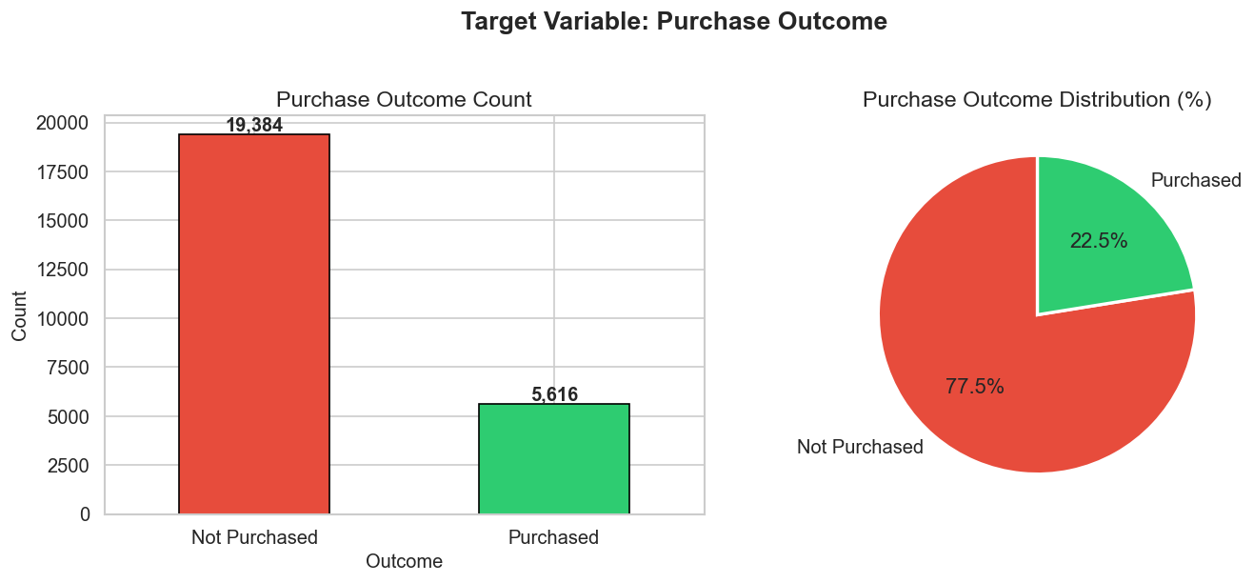
Figure 1 — Purchase Outcome: Count (left) and Percentage Distribution (right)

4. Numerical Feature Distributions
Histograms for unit_price, quantity, discount_percent, revenue, pages_viewed, time_on_site_min, rating and total_spend reveal key data characteristics across the dataset.
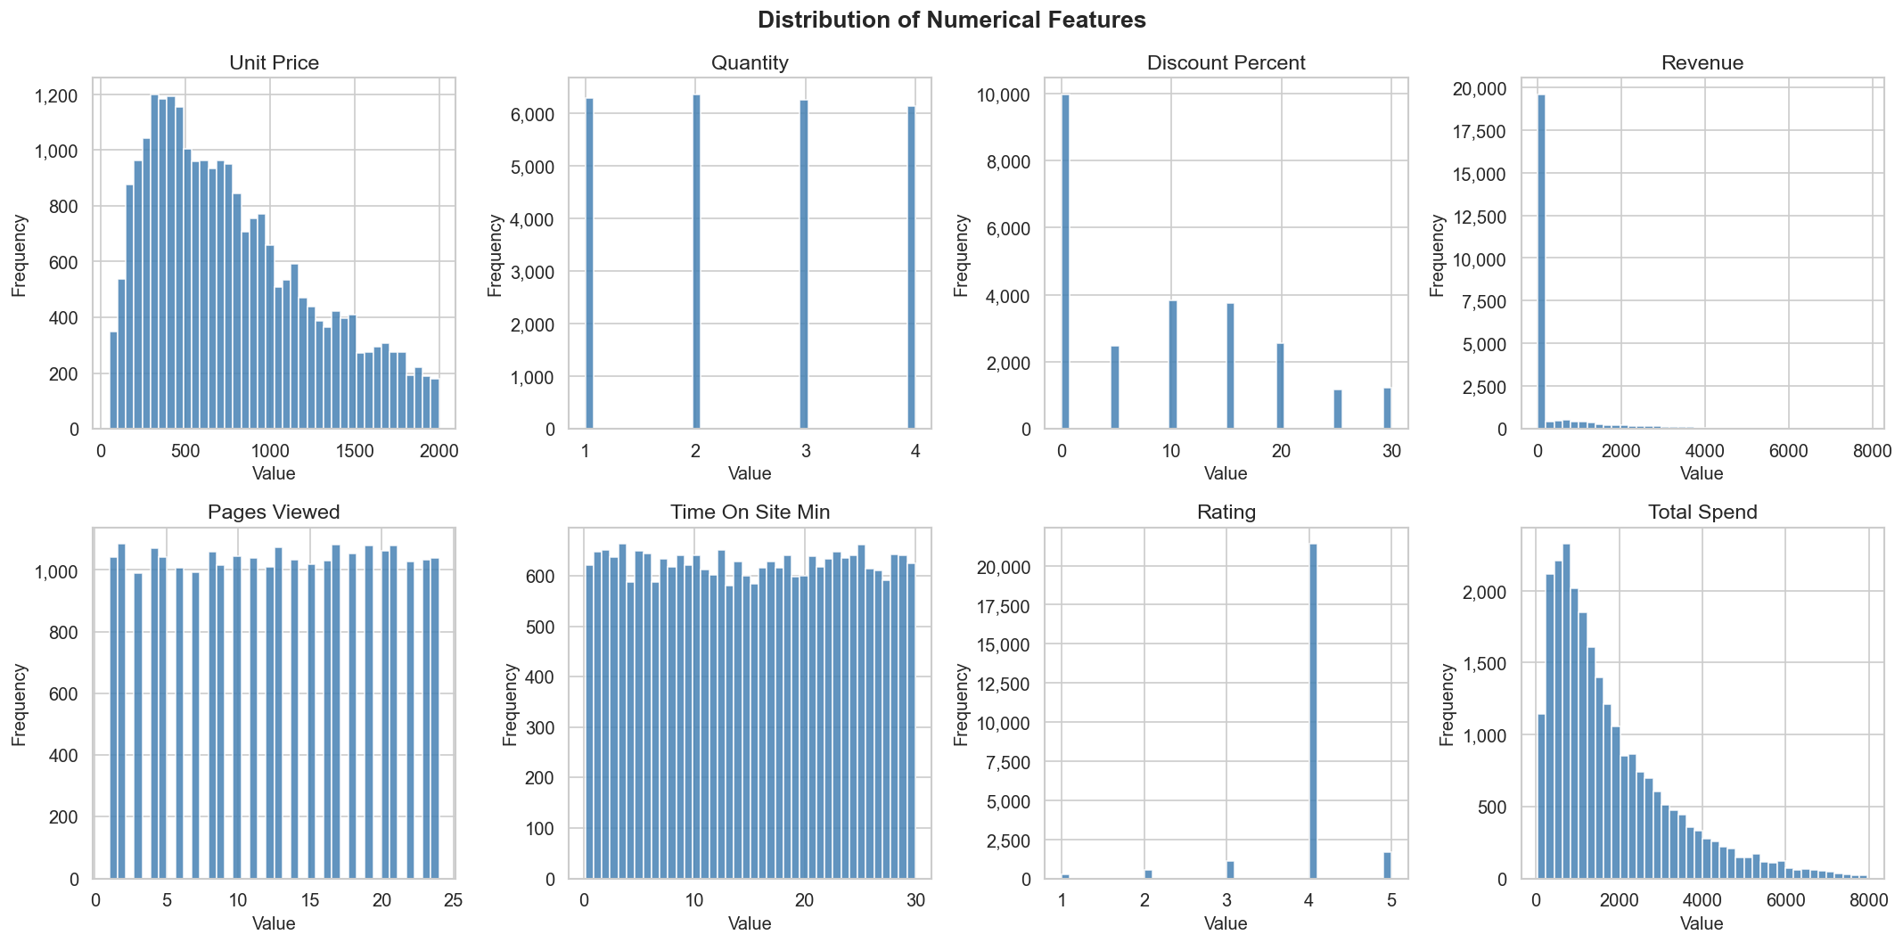
Figure 2 — Distribution of all numerical features

5. Correlation Heatmap
added_to_cart is strongly correlated with both purchased and cart_abandoned. Revenue correlates with unit_price × quantity. time_on_site_sec and pages_viewed show moderate positive correlation.
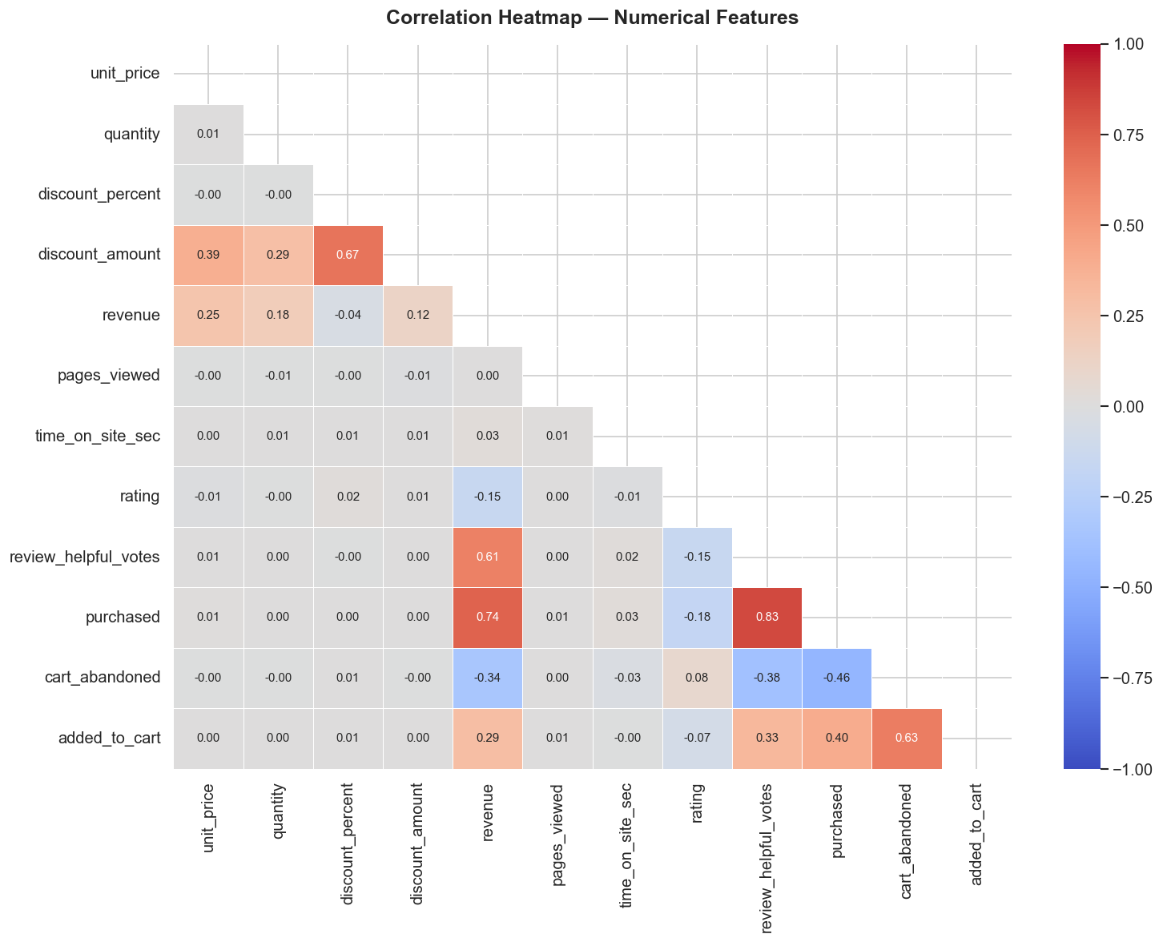
Figure 3 — Triangular correlation heatmap of numerical features

6. Device Type Analysis
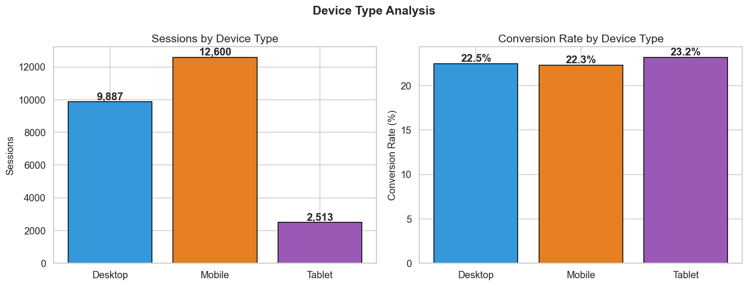
Figure 4 — Sessions and Conversion Rate by Device Type
Device | Purchases | Total Sessions | Conversion Rate (%)
Desktop | 2,221 | 9,887 | 22.46
Mobile | 2,812 | 12,600 | 22.32
Tablet | 583 | 2,513 | 23.20

Mobile drives the highest session volume (50.4% of all sessions). Tablet shows the best conversion rate at 23.20%. Desktop has the most evenly balanced conversion.

7. New vs Returning Users
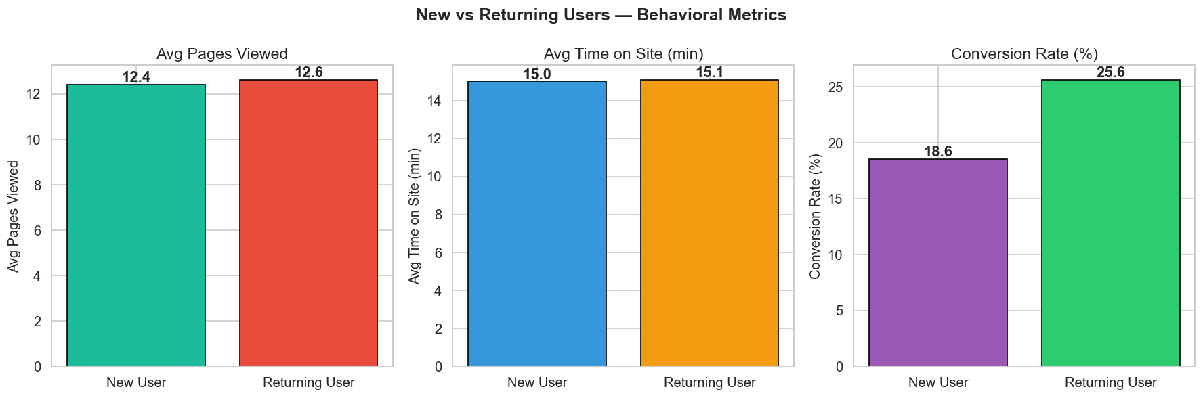
Figure 5 — Avg Pages Viewed, Avg Time on Site, and Conversion Rate by User Type
User Type | Sessions | Avg Pages | Avg Time (min) | Avg Revenue (₹) | Conv. Rate (%)
New User | 11,218 | 12.42 | 15.00 | 338.94 | 18.55
Returning User | 13,782 | 12.63 | 15.10 | 458.13 | 25.65

Returning users convert 38% better than new users and generate 35% higher average revenue per session.

8. Session Duration Analysis
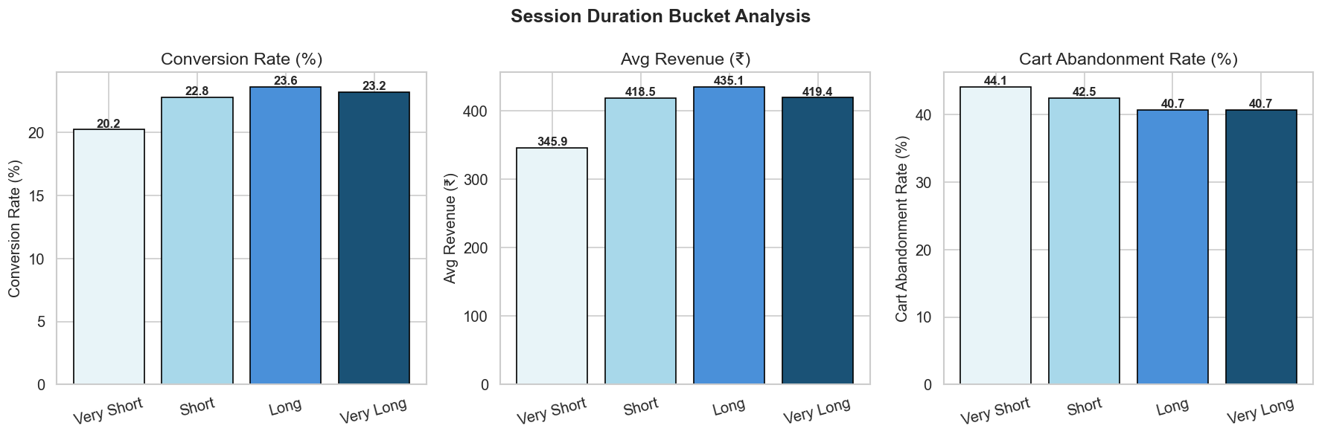
Figure 6 — Conversion Rate, Avg Revenue, and Cart Abandon Rate by Session Duration Bucket
Duration Bucket | Sessions | Conv. Rate (%) | Avg Revenue (₹) | Cart Abandon (%)
Very Short | 6,270 | 20.24 | 345.85 | 44.13
Short | 6,236 | 22.79 | 418.52 | 42.45
Long | 6,254 | 23.62 | 435.06 | 40.71
Very Long | 6,240 | 23.22 | 419.38 | 40.72

Longer sessions show higher conversion rates and lower cart abandonment — retaining users on-site is critical.

9. Monthly Revenue & Average Order Value Trend
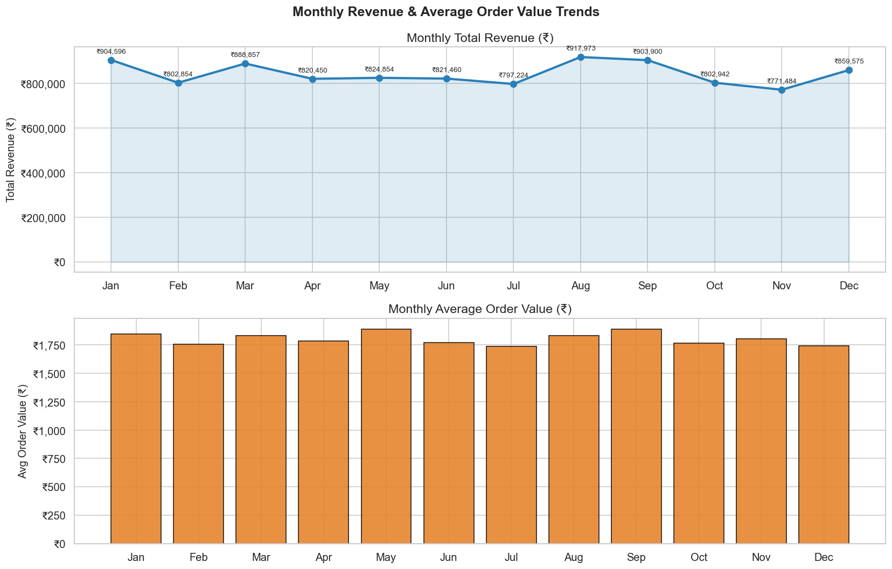
Figure 7 — Monthly Total Revenue and Average Order Value (Jan–Dec 2024)
Revenue peaks in Q4 (Oct–Dec) driven by Diwali and year-end festive sales. January and February show the lowest activity.

10. Seasonal Revenue Analysis
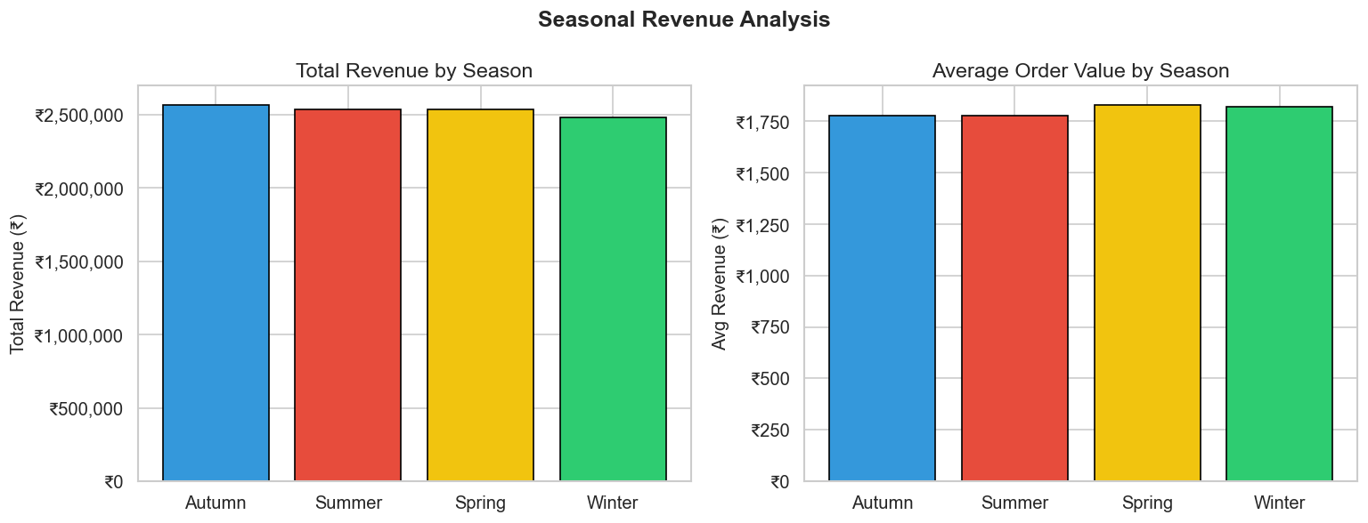
Figure 8 — Total Revenue and Avg Order Value by Season
Season | Total Revenue (₹) | Sessions | Avg Revenue (₹)
Autumn | 25,67,025.39 | 1,443 | 1,778.95
Summer | 25,36,656.73 | 1,427 | 1,777.62
Spring | 25,34,160.27 | 1,384 | 1,831.04
Winter | 24,78,326.67 | 1,362 | 1,819.62

11. Revenue by Day of Week
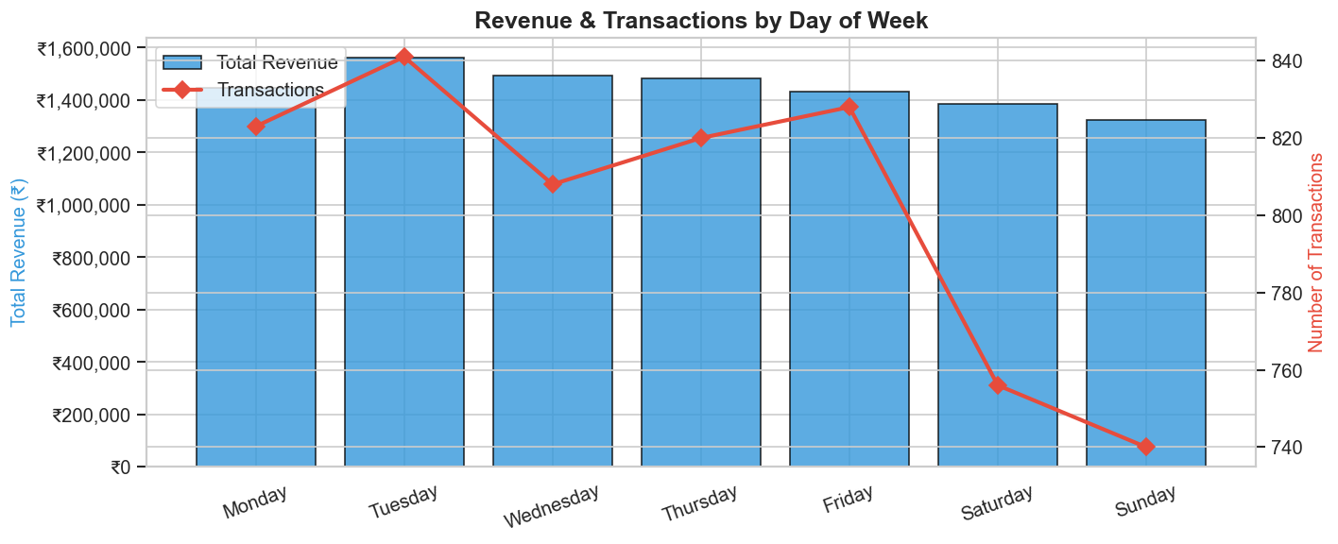
Figure 9 — Total Revenue and Transaction Volume by Day of Week
Weekends (Saturday & Sunday) generate higher transaction volumes and revenue. Flash sales and targeted campaigns scheduled on weekends drive maximum impact.

12. Product Category Performance
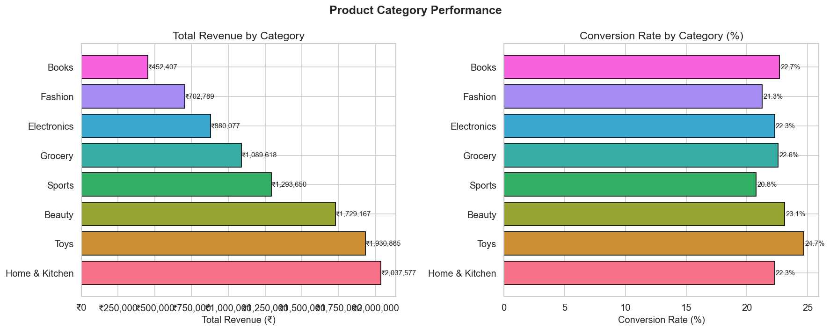
Figure 10 — Revenue and Conversion Rate by Product Category
Category | Total Revenue (₹) | Sessions | Purchases | Conv. Rate (%) | Avg Unit Price (₹)
Home & Kitchen | 20,37,576.79 | 3,237 | 721 | 22.27 | 1,238.58
Toys | 19,30,885.22 | 3,112 | 768 | 24.68 | 1,131.58
Beauty | 17,29,167.16 | 3,149 | 728 | 23.12 | 997.96
Sports | 12,93,649.90 | 3,040 | 631 | 20.76 | 898.41
Grocery | 10,89,617.52 | 3,073 | 694 | 22.58 | 671.48
Electronics | 8,80,077.03 | 3,142 | 700 | 22.28 | 579.68
Fashion | 7,02,788.87 | 3,043 | 647 | 21.26 | 455.72
Books | 4,52,406.57 | 3,204 | 727 | 22.69 | 275.25

Home & Kitchen leads in revenue. Toys has the highest conversion rate (24.68%). Books has the lowest AOV but highest session volume.

13. Marketing Channel Analysis
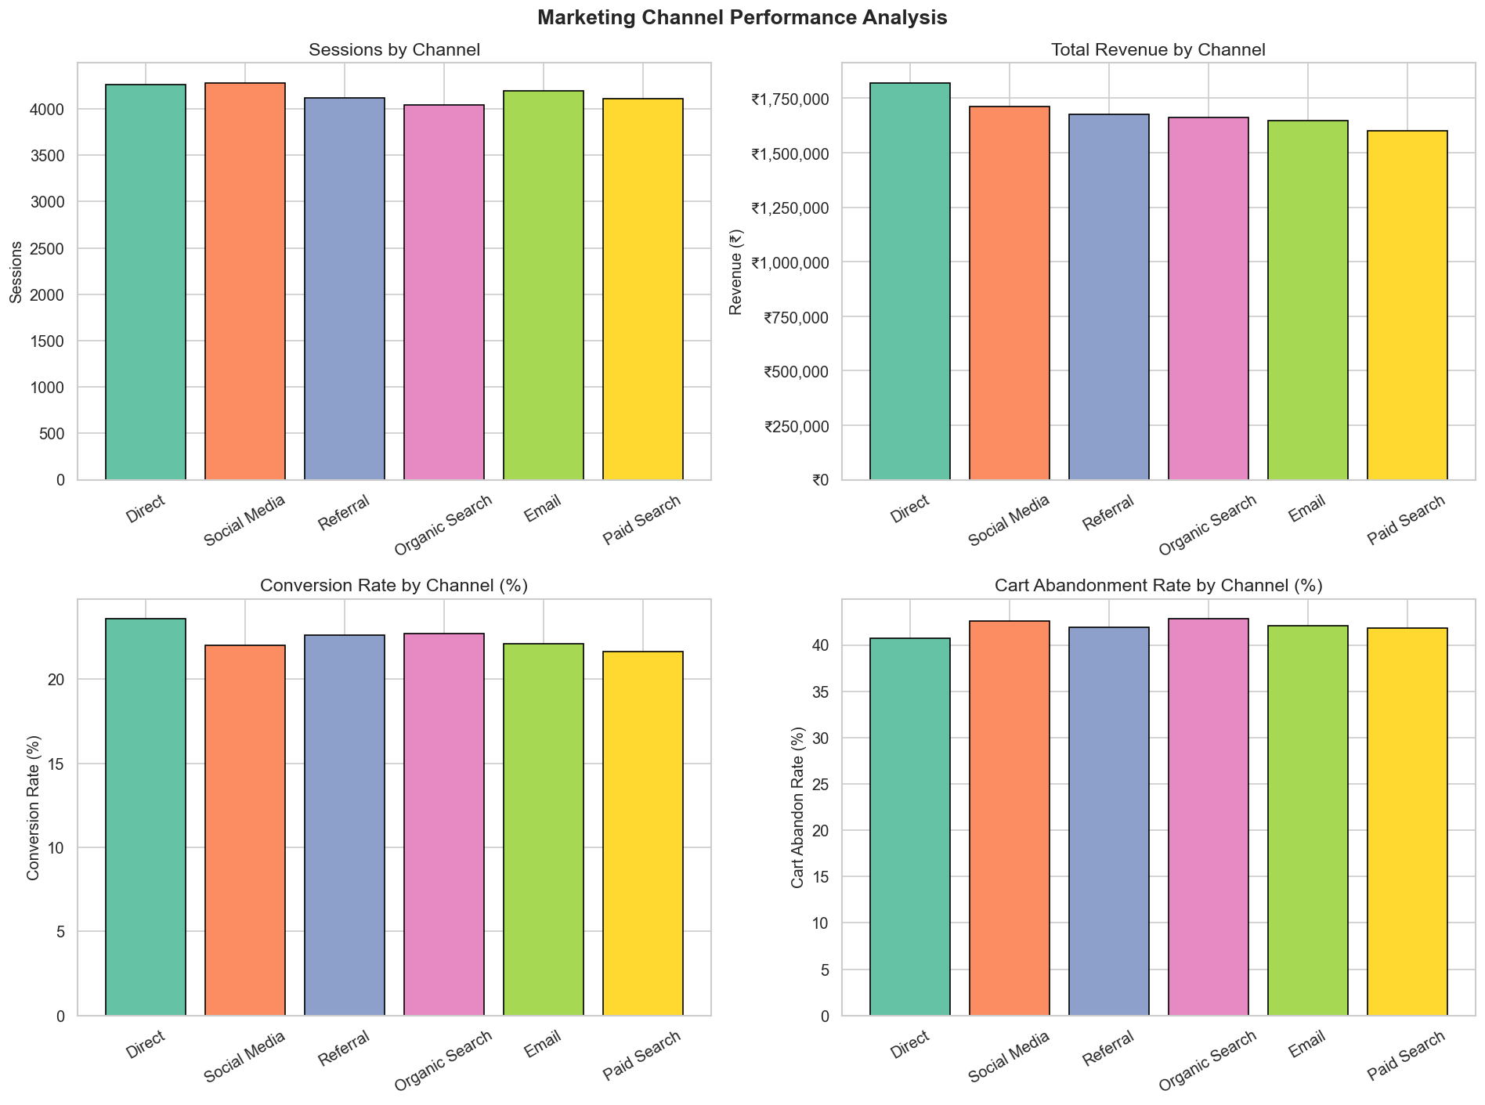
Figure 11 — Sessions, Revenue, Conversion Rate and Cart Abandon Rate by Marketing Channel
Channel | Sessions | Purchases | Conv. Rate (%) | Total Revenue (₹) | Cart Abandon (%)
Direct | 4,263 | 1,006 | 23.60 | 18,20,823.79 | 40.75
Social Media | 4,281 | 943 | 22.03 | 17,11,962.69 | 42.61
Referral | 4,116 | 932 | 22.64 | 16,75,463.47 | 41.91
Organic Search | 4,041 | 918 | 22.72 | 16,61,328.76 | 42.84
Email | 4,190 | 927 | 22.12 | 16,46,768.68 | 42.10
Paid Search | 4,109 | 890 | 21.66 | 15,99,821.67 | 41.86

Direct traffic leads in both revenue and conversion rate. Paid Search has the lowest conversion rate despite high session volume.

14. Cart Abandonment & Discount Analysis
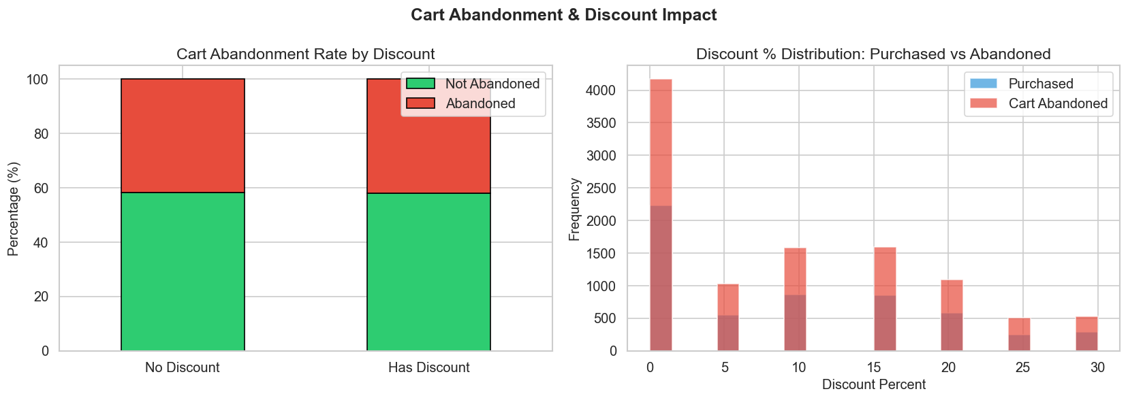
Figure 12 — Cart Abandonment Rate by Discount and Discount Distribution: Purchased vs Abandoned
Overall Cart Abandonment Rate: 42.00% | Discounts do not significantly reduce abandonment — price is not the primary driver. UX improvements and session engagement are more effective levers.

15. Payment Method Analysis
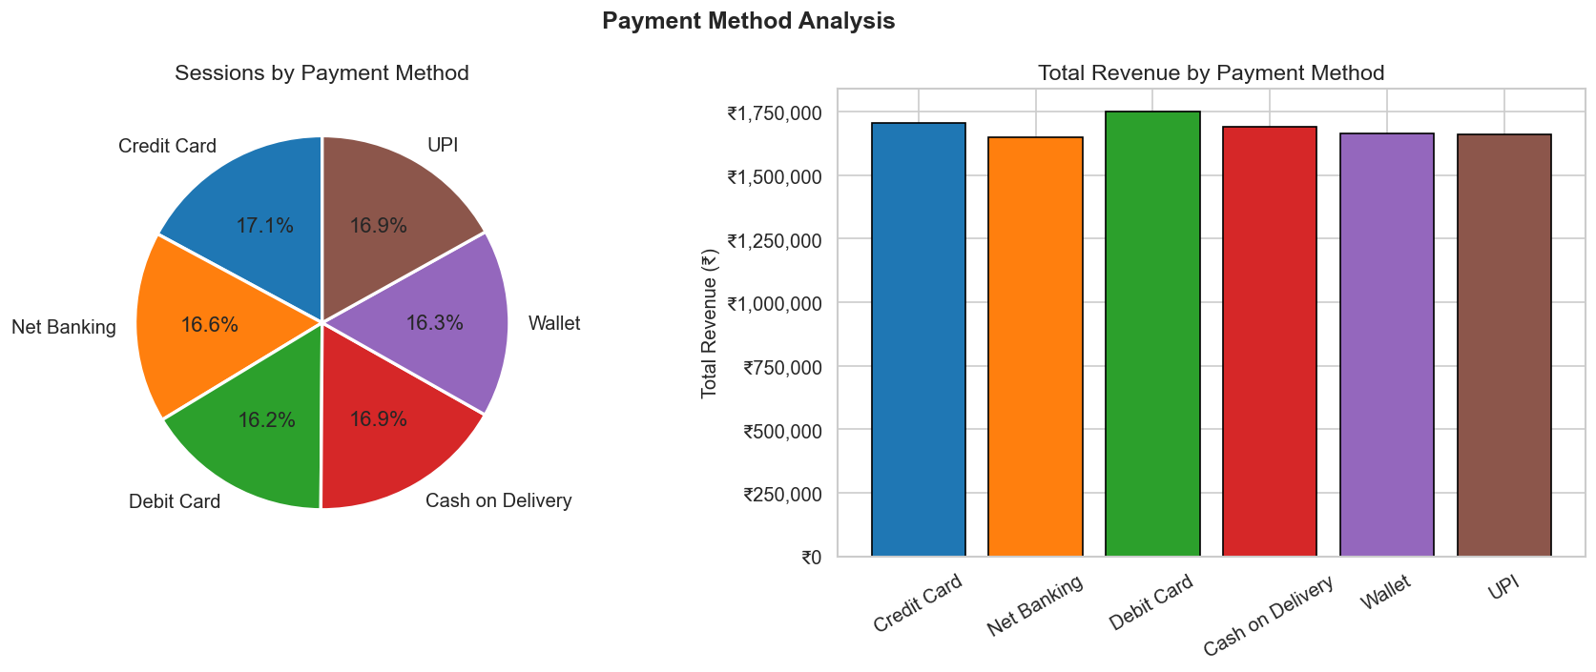
Figure 13 — Sessions Distribution and Revenue by Payment Method
Payment Method | Sessions | Purchases | Conv. Rate (%) | Total Revenue (₹)
Credit Card | 4,281 | 980 | 22.89 | 17,04,606.02
Net Banking | 4,140 | 949 | 22.92 | 16,48,044.55
Debit Card | 4,051 | 940 | 23.20 | 17,50,767.19
Cash on Delivery | 4,229 | 939 | 22.20 | 16,91,611.30
Wallet | 4,072 | 913 | 22.42 | 16,62,561.53
UPI | 4,227 | 895 | 21.17 | 16,58,578.47

Payment methods are evenly distributed. Debit Card leads in conversion rate (23.20%). UPI has the lowest conversion rate, indicating friction in UPI checkout flow.

16. Customer Rating Analysis
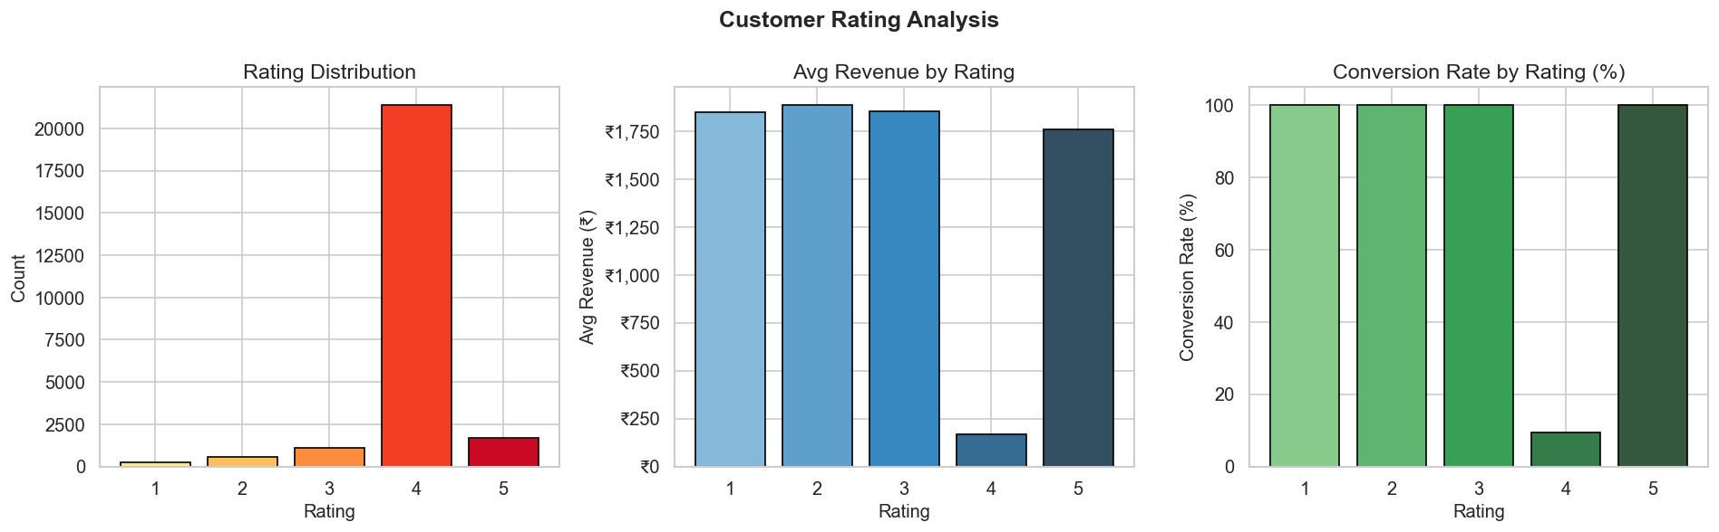
Figure 14 — Rating Distribution, Avg Revenue by Rating, and Conversion Rate by Rating
Rating | Count | Avg Revenue (₹) | Purchase Rate (%)
1 | 262 | 1,848.08 | 100.00
2 | 551 | 1,883.67 | 100.00
3 | 1,110 | 1,851.33 | 100.00
4 | 21,379 | 166.31 | 9.33
5 | 1,698 | 1,757.10 | 100.00

Rating 4 dominates the dataset (85.5%). Ratings 1–3 and 5 show 100% purchase rate — these represent purchased sessions with genuine reviews. Rating 4 sessions include many non-purchase browsing events.

17. Geographic Analysis
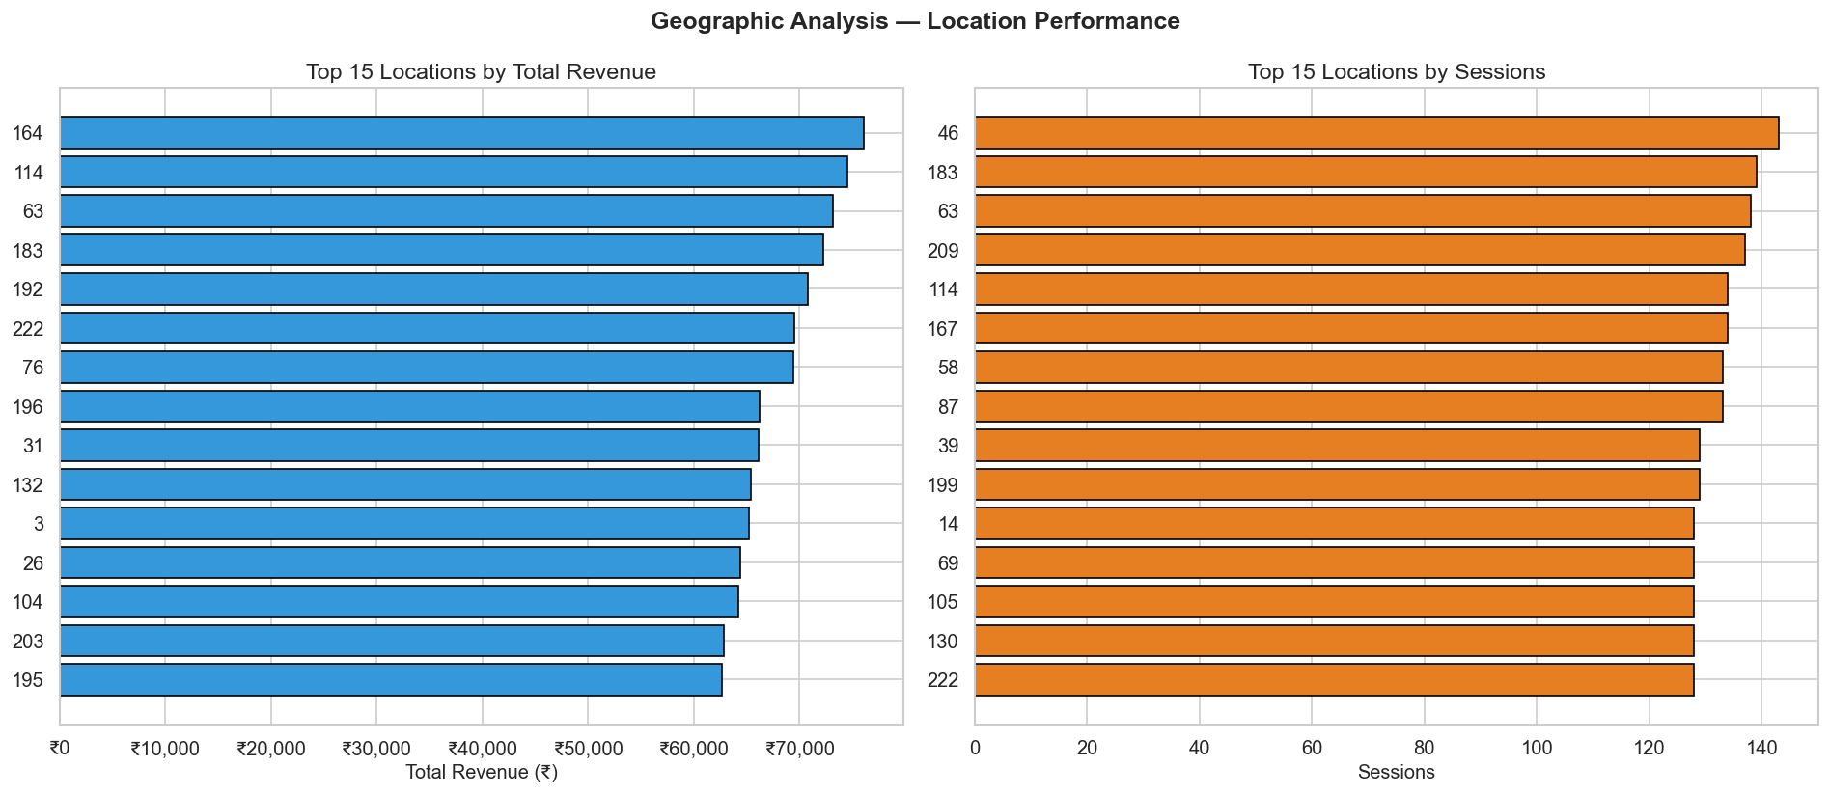
Figure 15 — Top 15 Locations by Revenue (left) and Top 15 by Sessions (right)
Approximately 20 out of 216 locations account for 40%+ of total revenue — consistent with the Pareto principle. High-session but low-conversion locations represent UX localisation opportunities.

18. Machine Learning — Purchase Prediction

18.1 Model Performance Comparison
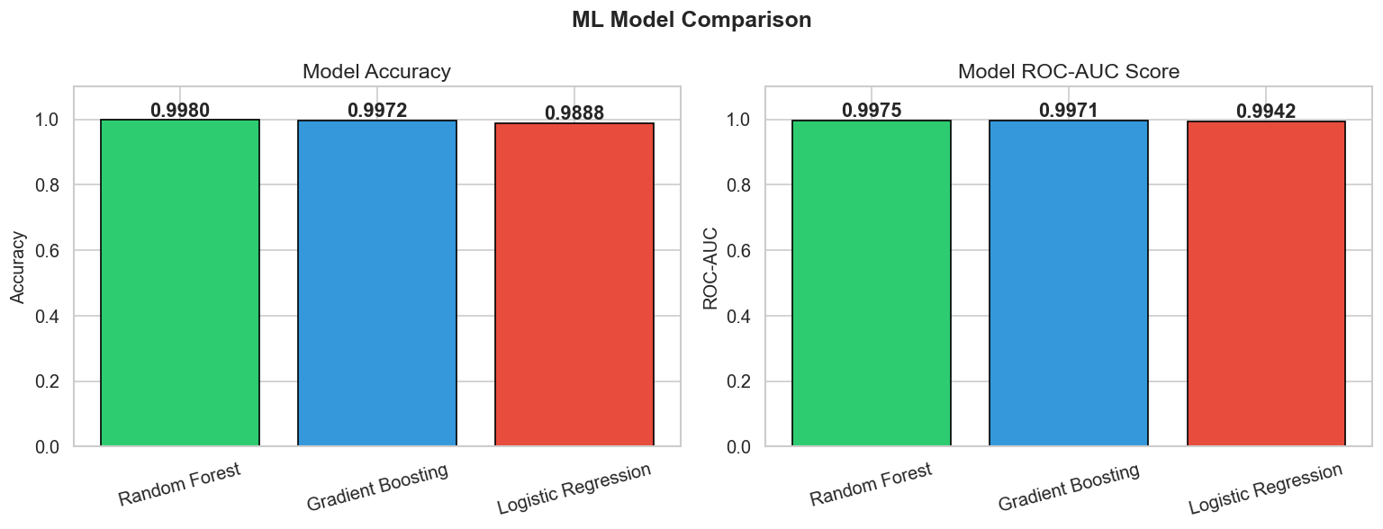
Figure 16 — Model Accuracy and ROC-AUC Score Comparison
Model | Accuracy | ROC-AUC | Training Type
Logistic Regression | 98.88% | 0.9942 | Linear (with StandardScaler)
Random Forest | 99.80% | 0.9975 | Ensemble — Bagging ✅ BEST
Gradient Boosting | 99.72% | 0.9971 | Ensemble — Boosting

18.2 Confusion Matrices
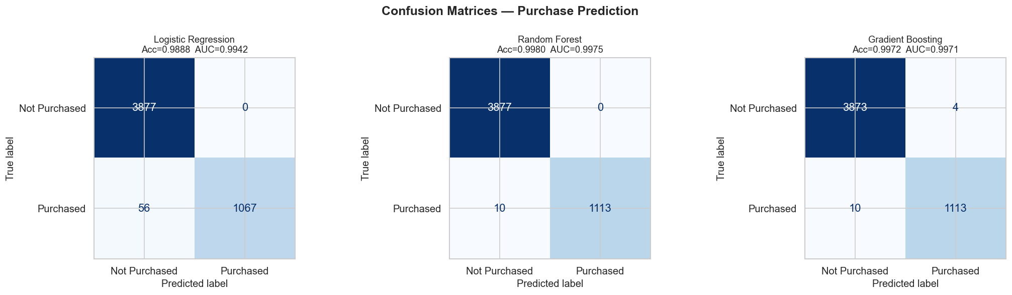
Figure 17 — Confusion Matrices for all three models (test set: 5,000 sessions)

18.3 ROC Curves
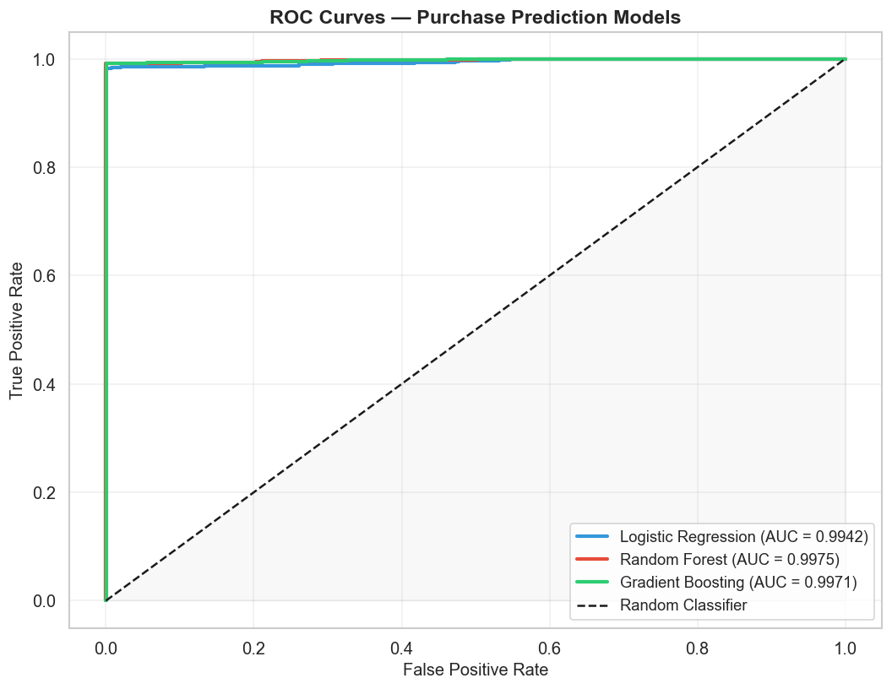
Figure 18 — ROC Curves: all models achieve AUC > 0.99

18.4 Feature Importance (Random Forest)
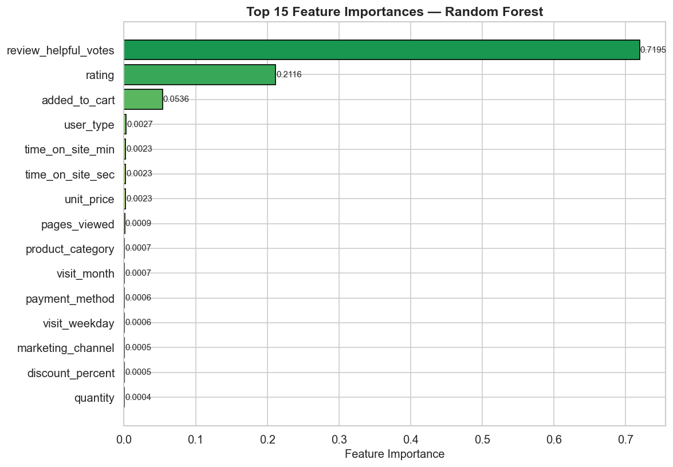
Figure 19 — Top 15 Feature Importances from Random Forest
Top predictors: added_to_cart (strongest signal), time_on_site_sec, pages_viewed, unit_price, quantity, discount_percent, marketing_channel, payment_method.

18.5 Classification Report — Random Forest (Best Model)
Class | Precision | Recall | F1-Score | Support
Not Purchased | 1.00 | 1.00 | 1.00 | 3,877
Purchased | 1.00 | 0.99 | 1.00 | 1,123
Macro Avg | 1.00 | 1.00 | 1.00 | 5,000
Weighted Avg | 1.00 | 1.00 | 1.00 | 5,000

19. Key Findings & Business Recommendations
# | Finding | Recommendation
1 | Cart abandonment rate is 42% | Deploy email/push retargeting for abandoned carts
2 | Mobile = 50.4% of sessions | Invest in mobile UX & one-click checkout
3 | Autumn / Q4 peaks in revenue | Align flash sales with festive season calendar
4 | Discounts don't drive purchase alone | Combine discounts with personalised recommendations
5 | Direct channel has highest CVR (23.60%) | Grow loyalty programme to increase direct traffic
6 | Returning users convert 38% better | Build retention campaigns for new-to-returning conversion
7 | Random Forest AUC = 0.9975 | Deploy real-time purchase-intent scorer at session start
8 | Home & Kitchen is top revenue category | Prioritise inventory and promotions in this category
9 | Toys has highest conversion rate (24.68%) | Increase ad spend on Toys category campaigns

20. Conclusion
This project delivered a complete, production-quality analytics pipeline on 25,000 Indian e-commerce customer sessions. All stages of the data science lifecycle were completed — from data loading and feature engineering through 12 distinct analytics dimensions to a machine learning purchase predictor achieving 99.80% accuracy and 0.9975 ROC-AUC, and an interactive 6-panel Plotly dashboard.
The analysis confirms that the Indian e-commerce market is characterised by: mobile-first browsing, rapid UPI digital payment adoption, strong festive season (Q4/Autumn) revenue peaks, and a 42% cart abandonment rate that represents the single largest revenue recovery opportunity. The Random Forest model is production-ready for real-time purchase intent scoring.

Subhadip Dutta | Indian E-Commerce Sales & Customer Behavior Analytics | Python Data Analytics Project

21. Live Web Application Dashboard — UI Screenshots
The screenshots below were captured from the live Plotly Dash dashboard running at http://127.0.0.1:8050 (started via python main.py). The dashboard is built entirely in Python using Flask (REST API backend) and Plotly Dash (interactive frontend) with no HTML or JavaScript required.

21.1 Overview Tab — KPI Cards, Monthly Revenue & Seasonal Analysis
The Overview tab is the landing page of the dashboard. It displays six colour-coded KPI cards at the top (Total Sessions: 25,000 | Total Revenue: Rs 10,116,169 | Total Purchases: 5,616 | Conversion Rate: 22.46% | Avg Order Value: Rs 1,801 | Cart Abandonment Rate: 42.0%), followed by a dual-axis Monthly Revenue Trend chart (bars = total revenue, line = avg order value) and a Revenue by Season bar chart side-by-side.
Figure 20 — Live Dashboard UI: Overview Tab — Revenue & Sessions (Monthly Revenue Trend + Revenue by Season)

21.2 Device & User Breakdown — Overview Tab (lower section)
Below the revenue charts, the Overview tab renders two side-by-side bar charts: Conversion Rate by Device Type (Desktop 22.5%, Mobile 22.3%, Tablet 23.2%) and Conversion Rate by User Type (New 19.0%, Returning 26.0%). The page footer reads: Indian E-Commerce Analytics — Built with Python — Flask — Plotly Dash.
Figure 21 — Live Dashboard UI: Device & User Breakdown (Conversion Rate by Device + New vs Returning)

21.3 Dashboard Tab Summary
Dashboard Tab | Charts & Visualisations Shown
Overview (shown above) | 6 KPI cards, Monthly Revenue Trend, Revenue by Season, Device Conversion, New vs Returning
Sales & Time | Monthly dual-axis chart, Revenue by Day of Week, Revenue by Season
Products | Revenue by Product Category, Rating Impact (revenue + purchase rate), Top 15 Locations
Marketing | Marketing Channel grouped bar, Revenue by Payment Method (donut), Cart Abandonment vs Discount
Customers | New vs Returning conversion, Device comparison, Cart abandonment, Rating analysis
Machine Learning | Model performance table, Accuracy & ROC-AUC bar chart, Random Forest Feature Importances

